## Reflections Vol I Nov 11-Sep 13.pdf - Page 1

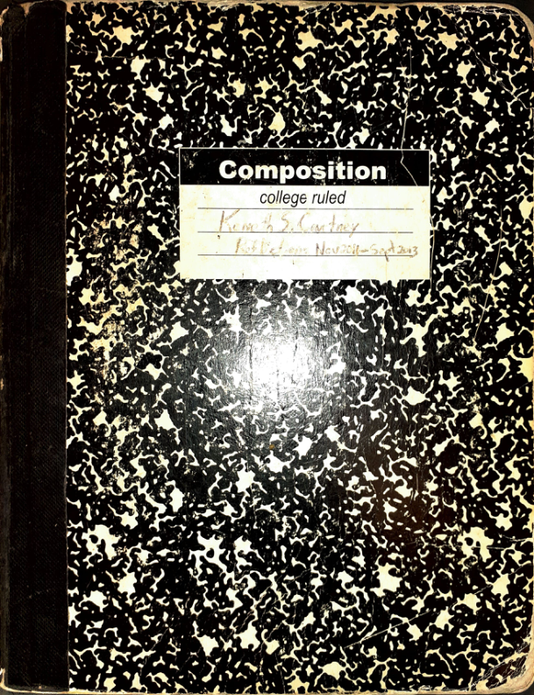

Here are the extracted texts from the provided images:  
  
**Image 1:**  
  
```  
Composition  
college ruled  
Kenneth Courtney   
Res. Entries: Nov 2011 - Sept 2013  
```  
  
**Image 2:**  
  
```  
Monday | Tuesday | Wednesday | Thursday | Friday  
  
Mutual (772) 579-3705 (see pg 13)  
  
Ohio Interstate Compact Office  
1-866-472-6446 Gail Burns  
  
Securus Phone Account 800-844-6591  
  
TIME:  
8 a.m. Pacific  
9 a.m. Mountain  
10 a.m. Central  
11 a.m. Eastern  
  
New York | Los Angeles | London | Moscow | Tokyo | Beijing  
```  
  
**Image 3:**  
  
```  
Kenneth Courtney  
  
CONTENTS  
  
11.10.06.01 Entry SL 3  
11.10.06.02 "Forever" + Jonathan Moran 4  
11.10.06.03 Fish Story by M Clarke 6  
11.10.06.04 Stephen Bayley 7  
11.10.07.01 Race Class Doing Time 9  
11.10.07.02 Remnants 11  
11.10.07.03 Hello Lancers 12  
11.10.08.01 Jonathan & Bree S.A. 12  
11.11.03.01 I'm Michael 19  
11.11.04.01 Accountants & Atrocities 20  
11.11.09.01 Poetry and Prayer 'Cujo' 22  
11.11.20.01 Theresa Blasphemy 24  
11.11.03.02 Talk on Empires 25  
11.11.01.01 Teenager's Walk (JFPH) 26  
11.11.04.04 I'm Torn 27  
11.11.10.01 Latins & Comics Wed+ Thu 28  
11.11.12.01 Cheers (Life) for Health 29  
11.11.12.01 SAT Sherlock Holmes 29  
11.11.20.01 College Blessings 30  
11.11.27.01 Washer's Gone 31  
11.11.28.01 Influences (Education) 31  
11.11.30.01 Immerson 32  
11.11.30.02 Teen Comedians 32  
11.12.02.01 Dickerson’s A*** S*** 32  
11.12.06.01 I am Robert 34  
11.11.10.01 Tony Robbins & A.J. Ayer 34  
11.11.28.01 Grandmother's Lazor 34  
11.11.18.01 Bonafacio Puppy's 35  
11.11.11.01 One and Only Grandpa 36  
11.11.30.01 Purolator 37  
11.11.15.01 It could happen 37  
11.11.15.01 Deborah's Lonely Gasp 38  
11.11.14.01 Real Estate 38  
11.11.30.01 Baseball Comparisons 39  
11.11.15.01 My Birthday 39  
11.12.05.01 Numbers Game 40  
11.11.11.01 Steve's Tech Talk 41  
11.12.04.01 I'm Meeting 42  
11.12.04.01 Facebook Zuckerberg 41  
11.12.07.01 My Spy Scope Ops 4  
11.12.12.01 Dennis - I'm Here! Jail Tidabra 41  
11.12.08.01 G.P.* Entertainment 43  
11.12.08.01 G.P.scwo music 43  
11.12.19.01 I'm Infamous 41  
11.12.05.01 Dennis & Me Fulson Family Book 44  
11.12.08.01 Francis (West Wing) Dialogue 44  
11.12.15.01 News Too High Emit Barronate 45  
11.12.15.01 Brett Kavanaugh 45  
11.12.19.01 Macaroo 46  
11.12.20.01 Four Pictures 46  
11.12.20.01 Dilemma in Winterton 47  
11.12.22.01 Open a casino 47  
11.12.22.01 TD Thomas Koch Englishissed 48  
11.12.20.01 Politician Bros 48  
11.12.23.01 Sci-Fi Quotes 49  
11.12.25.01 Holding Coffee (Kozak) Patent 49  
12.01.04.01 Hello from Court 49  
12.01.08.01 Mysteries of Attachments 50  
12.01.14.01 Francenlpark 52  
12.01.21.01 Genes G.R 52  
12.01.21.02 Pelley Carmos M 53  
12.01.26.01 Kevin and Prison 53  
12.01.21.01 Who's Dominant 54  
12.02.01.01 Looks 55  
12.02.04.01 Tim Inc. Big Funny Gilmans/Offsang 54  
12.02.24.01 M.-Raymond Aaron/Jona 54  
12.02.26.01 Living God's Paper/Newspaper 55  
12.02.22.01 Volt I.J.A. Kierant Ricesky PIE 54  
12.02.29.01 3 x More PIE 56  
12.03.26.01 Marathon 69  
12.02.28.01 Unknown 56  
12.12.18.01 Guess and Days 57  
12.12.18.01 Poetry C 58  
11.11.28.01 Letters JESUS & POEM 59  
12.03.15.01 Newspaper Infamous Army 58  
12.03.22.01 Need and Participating Paragraph 59  
12.12.20.2012 Heroes Holytown 59  
12.02.22.01 How to Write a Story 60  
12.12.25.01 Case 60  
12.12.21.01 50 Millions 60  
12.12.21.01 Spikes into Rebar Prere 60  
12.11.25.01 I'm Mutesa 61  
12.12.02.01 Nurse Williams Bello Long Arms 61  
12.12.15.01 (Maint) LT - WP Harris Special 62  
12.12.15.01 Love from Px! First Kiss (X Ray) 61  
12.03.04.01 Teenage Pooh 62  
12.12.18.01 Drafts R Euclid Karl Fust 62  
12.01.25.01 Shopping Mall and Mevnet 63  
12.02.28.01 Nurse 62  
12.12.17.01 Tim Speculates 64  
12.11.17.01 Spin & Move+ Live 64  
12.12.20.01 I Love You 64   
12.04.01.01 Cheating Me and 64  
12.11.25.01 Haitian Talk 64  
12.12.22.01 Full Postmanther Funderis 65  
12.11.21.01 My Speculations 66  
12.01.24.2012 Plus Time+ Anatomy 65  
12.04.19.01 "Sino Blue" Talks Movie 68  
12.01.21.01 Case 66  
12.11.07.01 Find Panama 66  
12.11.08.01 Liza and Math Rush 66  
12.11.01.01 Tag Sci-Fi Upward 66  
12.12.12.01 Song 67  
12.04.26.01 PM Address 69  
12.03.01.01 Background 69  
11.12.01.01 PIA from Ex 62670. " I.G. META 67  
12.03.22.01 PIA Fathers? GHOST PROTOCOL 75  
12.03.13.05 TM/British only one question rec'd 75  
12.03.17.01 Home - Prison 74  
12.12.24.01 John's Wedding Kevin Coleman 75  
12.12.25.01 ' Case from Enteral 7 6  
12.12.25.01 KG Miz Theater New Year's Eve 77  
12.11.17.01 Funny Jokes 73  
12.11.18.01 Kevin's eve - Quietenest Level Bus. 68  
12.01.25.01 L.I. - MAG Wood impressed 60   
12.12.20.01 Tim Speculates 68  
12.10.01.01 Write me into an Escape 63  
  
12.12.05

## Reflections Vol I Nov 11-Sep 13.pdf - Page 2

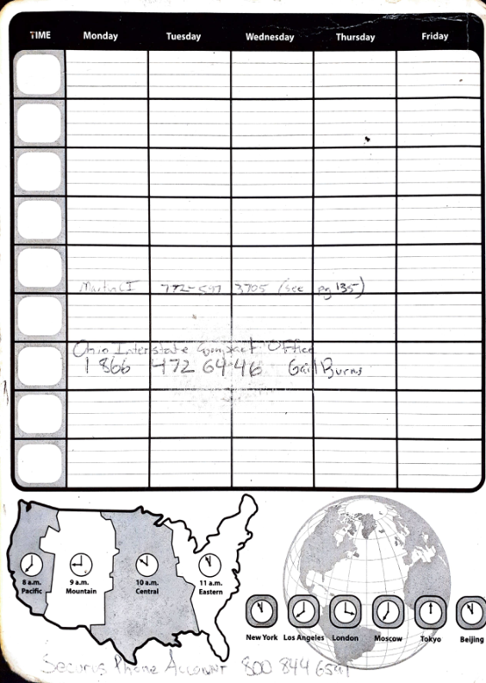

Here are the extracted texts from the provided images:  
  
**Image 1:**  
  
```  
Composition  
college ruled  
Kenneth Courtney   
Res. Entries: Nov 2011 - Sept 2013  
```  
  
**Image 2:**  
  
```  
Monday | Tuesday | Wednesday | Thursday | Friday  
  
Mutual (772) 579-3705 (see pg 13)  
  
Ohio Interstate Compact Office  
1-866-472-6446 Gail Burns  
  
Securus Phone Account 800-844-6591  
  
TIME:  
8 a.m. Pacific  
9 a.m. Mountain  
10 a.m. Central  
11 a.m. Eastern  
  
New York | Los Angeles | London | Moscow | Tokyo | Beijing  
```  
  
**Image 3:**  
  
```  
Kenneth Courtney  
  
CONTENTS  
  
11.10.06.01 Entry SL 3  
11.10.06.02 "Forever" + Jonathan Moran 4  
11.10.06.03 Fish Story by M Clarke 6  
11.10.06.04 Stephen Bayley 7  
11.10.07.01 Race Class Doing Time 9  
11.10.07.02 Remnants 11  
11.10.07.03 Hello Lancers 12  
11.10.08.01 Jonathan & Bree S.A. 12  
11.11.03.01 I'm Michael 19  
11.11.04.01 Accountants & Atrocities 20  
11.11.09.01 Poetry and Prayer 'Cujo' 22  
11.11.20.01 Theresa Blasphemy 24  
11.11.03.02 Talk on Empires 25  
11.11.01.01 Teenager's Walk (JFPH) 26  
11.11.04.04 I'm Torn 27  
11.11.10.01 Latins & Comics Wed+ Thu 28  
11.11.12.01 Cheers (Life) for Health 29  
11.11.12.01 SAT Sherlock Holmes 29  
11.11.20.01 College Blessings 30  
11.11.27.01 Washer's Gone 31  
11.11.28.01 Influences (Education) 31  
11.11.30.01 Immerson 32  
11.11.30.02 Teen Comedians 32  
11.12.02.01 Dickerson’s A*** S*** 32  
11.12.06.01 I am Robert 34  
11.11.10.01 Tony Robbins & A.J. Ayer 34  
11.11.28.01 Grandmother's Lazor 34  
11.11.18.01 Bonafacio Puppy's 35  
11.11.11.01 One and Only Grandpa 36  
11.11.30.01 Purolator 37  
11.11.15.01 It could happen 37  
11.11.15.01 Deborah's Lonely Gasp 38  
11.11.14.01 Real Estate 38  
11.11.30.01 Baseball Comparisons 39  
11.11.15.01 My Birthday 39  
11.12.05.01 Numbers Game 40  
11.11.11.01 Steve's Tech Talk 41  
11.12.04.01 I'm Meeting 42  
11.12.04.01 Facebook Zuckerberg 41  
11.12.07.01 My Spy Scope Ops 4  
11.12.12.01 Dennis - I'm Here! Jail Tidabra 41  
11.12.08.01 G.P.* Entertainment 43  
11.12.08.01 G.P.scwo music 43  
11.12.19.01 I'm Infamous 41  
11.12.05.01 Dennis & Me Fulson Family Book 44  
11.12.08.01 Francis (West Wing) Dialogue 44  
11.12.15.01 News Too High Emit Barronate 45  
11.12.15.01 Brett Kavanaugh 45  
11.12.19.01 Macaroo 46  
11.12.20.01 Four Pictures 46  
11.12.20.01 Dilemma in Winterton 47  
11.12.22.01 Open a casino 47  
11.12.22.01 TD Thomas Koch Englishissed 48  
11.12.20.01 Politician Bros 48  
11.12.23.01 Sci-Fi Quotes 49  
11.12.25.01 Holding Coffee (Kozak) Patent 49  
12.01.04.01 Hello from Court 49  
12.01.08.01 Mysteries of Attachments 50  
12.01.14.01 Francenlpark 52  
12.01.21.01 Genes G.R 52  
12.01.21.02 Pelley Carmos M 53  
12.01.26.01 Kevin and Prison 53  
12.01.21.01 Who's Dominant 54  
12.02.01.01 Looks 55  
12.02.04.01 Tim Inc. Big Funny Gilmans/Offsang 54  
12.02.24.01 M.-Raymond Aaron/Jona 54  
12.02.26.01 Living God's Paper/Newspaper 55  
12.02.22.01 Volt I.J.A. Kierant Ricesky PIE 54  
12.02.29.01 3 x More PIE 56  
12.03.26.01 Marathon 69  
12.02.28.01 Unknown 56  
12.12.18.01 Guess and Days 57  
12.12.18.01 Poetry C 58  
11.11.28.01 Letters JESUS & POEM 59  
12.03.15.01 Newspaper Infamous Army 58  
12.03.22.01 Need and Participating Paragraph 59  
12.12.20.2012 Heroes Holytown 59  
12.02.22.01 How to Write a Story 60  
12.12.25.01 Case 60  
12.12.21.01 50 Millions 60  
12.12.21.01 Spikes into Rebar Prere 60  
12.11.25.01 I'm Mutesa 61  
12.12.02.01 Nurse Williams Bello Long Arms 61  
12.12.15.01 (Maint) LT - WP Harris Special 62  
12.12.15.01 Love from Px! First Kiss (X Ray) 61  
12.03.04.01 Teenage Pooh 62  
12.12.18.01 Drafts R Euclid Karl Fust 62  
12.01.25.01 Shopping Mall and Mevnet 63  
12.02.28.01 Nurse 62  
12.12.17.01 Tim Speculates 64  
12.11.17.01 Spin & Move+ Live 64  
12.12.20.01 I Love You 64   
12.04.01.01 Cheating Me and 64  
12.11.25.01 Haitian Talk 64  
12.12.22.01 Full Postmanther Funderis 65  
12.11.21.01 My Speculations 66  
12.01.24.2012 Plus Time+ Anatomy 65  
12.04.19.01 "Sino Blue" Talks Movie 68  
12.01.21.01 Case 66  
12.11.07.01 Find Panama 66  
12.11.08.01 Liza and Math Rush 66  
12.11.01.01 Tag Sci-Fi Upward 66  
12.12.12.01 Song 67  
12.04.26.01 PM Address 69  
12.03.01.01 Background 69  
11.12.01.01 PIA from Ex 62670. " I.G. META 67  
12.03.22.01 PIA Fathers? GHOST PROTOCOL 75  
12.03.13.05 TM/British only one question rec'd 75  
12.03.17.01 Home - Prison 74  
12.12.24.01 John's Wedding Kevin Coleman 75  
12.12.25.01 ' Case from Enteral 7 6  
12.12.25.01 KG Miz Theater New Year's Eve 77  
12.11.17.01 Funny Jokes 73  
12.11.18.01 Kevin's eve - Quietenest Level Bus. 68  
12.01.25.01 L.I. - MAG Wood impressed 60   
12.12.20.01 Tim Speculates 68  
12.10.01.01 Write me into an Escape 63  
  
12.12.05

## Reflections Vol I Nov 11-Sep 13.pdf - Page 3

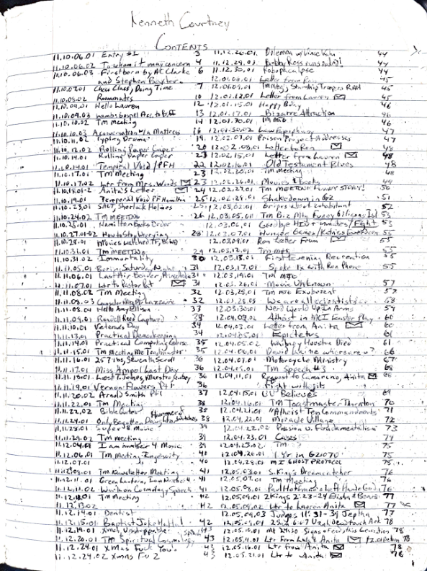

Here are the extracted texts from the provided images:  
  
**Image 1:**  
  
```  
Composition  
college ruled  
Kenneth Courtney   
Res. Entries: Nov 2011 - Sept 2013  
```  
  
**Image 2:**  
  
```  
Monday | Tuesday | Wednesday | Thursday | Friday  
  
Mutual (772) 579-3705 (see pg 13)  
  
Ohio Interstate Compact Office  
1-866-472-6446 Gail Burns  
  
Securus Phone Account 800-844-6591  
  
TIME:  
8 a.m. Pacific  
9 a.m. Mountain  
10 a.m. Central  
11 a.m. Eastern  
  
New York | Los Angeles | London | Moscow | Tokyo | Beijing  
```  
  
**Image 3:**  
  
```  
Kenneth Courtney  
  
CONTENTS  
  
11.10.06.01 Entry SL 3  
11.10.06.02 "Forever" + Jonathan Moran 4  
11.10.06.03 Fish Story by M Clarke 6  
11.10.06.04 Stephen Bayley 7  
11.10.07.01 Race Class Doing Time 9  
11.10.07.02 Remnants 11  
11.10.07.03 Hello Lancers 12  
11.10.08.01 Jonathan & Bree S.A. 12  
11.11.03.01 I'm Michael 19  
11.11.04.01 Accountants & Atrocities 20  
11.11.09.01 Poetry and Prayer 'Cujo' 22  
11.11.20.01 Theresa Blasphemy 24  
11.11.03.02 Talk on Empires 25  
11.11.01.01 Teenager's Walk (JFPH) 26  
11.11.04.04 I'm Torn 27  
11.11.10.01 Latins & Comics Wed+ Thu 28  
11.11.12.01 Cheers (Life) for Health 29  
11.11.12.01 SAT Sherlock Holmes 29  
11.11.20.01 College Blessings 30  
11.11.27.01 Washer's Gone 31  
11.11.28.01 Influences (Education) 31  
11.11.30.01 Immerson 32  
11.11.30.02 Teen Comedians 32  
11.12.02.01 Dickerson’s A*** S*** 32  
11.12.06.01 I am Robert 34  
11.11.10.01 Tony Robbins & A.J. Ayer 34  
11.11.28.01 Grandmother's Lazor 34  
11.11.18.01 Bonafacio Puppy's 35  
11.11.11.01 One and Only Grandpa 36  
11.11.30.01 Purolator 37  
11.11.15.01 It could happen 37  
11.11.15.01 Deborah's Lonely Gasp 38  
11.11.14.01 Real Estate 38  
11.11.30.01 Baseball Comparisons 39  
11.11.15.01 My Birthday 39  
11.12.05.01 Numbers Game 40  
11.11.11.01 Steve's Tech Talk 41  
11.12.04.01 I'm Meeting 42  
11.12.04.01 Facebook Zuckerberg 41  
11.12.07.01 My Spy Scope Ops 4  
11.12.12.01 Dennis - I'm Here! Jail Tidabra 41  
11.12.08.01 G.P.* Entertainment 43  
11.12.08.01 G.P.scwo music 43  
11.12.19.01 I'm Infamous 41  
11.12.05.01 Dennis & Me Fulson Family Book 44  
11.12.08.01 Francis (West Wing) Dialogue 44  
11.12.15.01 News Too High Emit Barronate 45  
11.12.15.01 Brett Kavanaugh 45  
11.12.19.01 Macaroo 46  
11.12.20.01 Four Pictures 46  
11.12.20.01 Dilemma in Winterton 47  
11.12.22.01 Open a casino 47  
11.12.22.01 TD Thomas Koch Englishissed 48  
11.12.20.01 Politician Bros 48  
11.12.23.01 Sci-Fi Quotes 49  
11.12.25.01 Holding Coffee (Kozak) Patent 49  
12.01.04.01 Hello from Court 49  
12.01.08.01 Mysteries of Attachments 50  
12.01.14.01 Francenlpark 52  
12.01.21.01 Genes G.R 52  
12.01.21.02 Pelley Carmos M 53  
12.01.26.01 Kevin and Prison 53  
12.01.21.01 Who's Dominant 54  
12.02.01.01 Looks 55  
12.02.04.01 Tim Inc. Big Funny Gilmans/Offsang 54  
12.02.24.01 M.-Raymond Aaron/Jona 54  
12.02.26.01 Living God's Paper/Newspaper 55  
12.02.22.01 Volt I.J.A. Kierant Ricesky PIE 54  
12.02.29.01 3 x More PIE 56  
12.03.26.01 Marathon 69  
12.02.28.01 Unknown 56  
12.12.18.01 Guess and Days 57  
12.12.18.01 Poetry C 58  
11.11.28.01 Letters JESUS & POEM 59  
12.03.15.01 Newspaper Infamous Army 58  
12.03.22.01 Need and Participating Paragraph 59  
12.12.20.2012 Heroes Holytown 59  
12.02.22.01 How to Write a Story 60  
12.12.25.01 Case 60  
12.12.21.01 50 Millions 60  
12.12.21.01 Spikes into Rebar Prere 60  
12.11.25.01 I'm Mutesa 61  
12.12.02.01 Nurse Williams Bello Long Arms 61  
12.12.15.01 (Maint) LT - WP Harris Special 62  
12.12.15.01 Love from Px! First Kiss (X Ray) 61  
12.03.04.01 Teenage Pooh 62  
12.12.18.01 Drafts R Euclid Karl Fust 62  
12.01.25.01 Shopping Mall and Mevnet 63  
12.02.28.01 Nurse 62  
12.12.17.01 Tim Speculates 64  
12.11.17.01 Spin & Move+ Live 64  
12.12.20.01 I Love You 64   
12.04.01.01 Cheating Me and 64  
12.11.25.01 Haitian Talk 64  
12.12.22.01 Full Postmanther Funderis 65  
12.11.21.01 My Speculations 66  
12.01.24.2012 Plus Time+ Anatomy 65  
12.04.19.01 "Sino Blue" Talks Movie 68  
12.01.21.01 Case 66  
12.11.07.01 Find Panama 66  
12.11.08.01 Liza and Math Rush 66  
12.11.01.01 Tag Sci-Fi Upward 66  
12.12.12.01 Song 67  
12.04.26.01 PM Address 69  
12.03.01.01 Background 69  
11.12.01.01 PIA from Ex 62670. " I.G. META 67  
12.03.22.01 PIA Fathers? GHOST PROTOCOL 75  
12.03.13.05 TM/British only one question rec'd 75  
12.03.17.01 Home - Prison 74  
12.12.24.01 John's Wedding Kevin Coleman 75  
12.12.25.01 ' Case from Enteral 7 6  
12.12.25.01 KG Miz Theater New Year's Eve 77  
12.11.17.01 Funny Jokes 73  
12.11.18.01 Kevin's eve - Quietenest Level Bus. 68  
12.01.25.01 L.I. - MAG Wood impressed 60   
12.12.20.01 Tim Speculates 68  
12.10.01.01 Write me into an Escape 63  
  
12.12.05

## Reflections Vol I Nov 11-Sep 13.pdf - Page 4

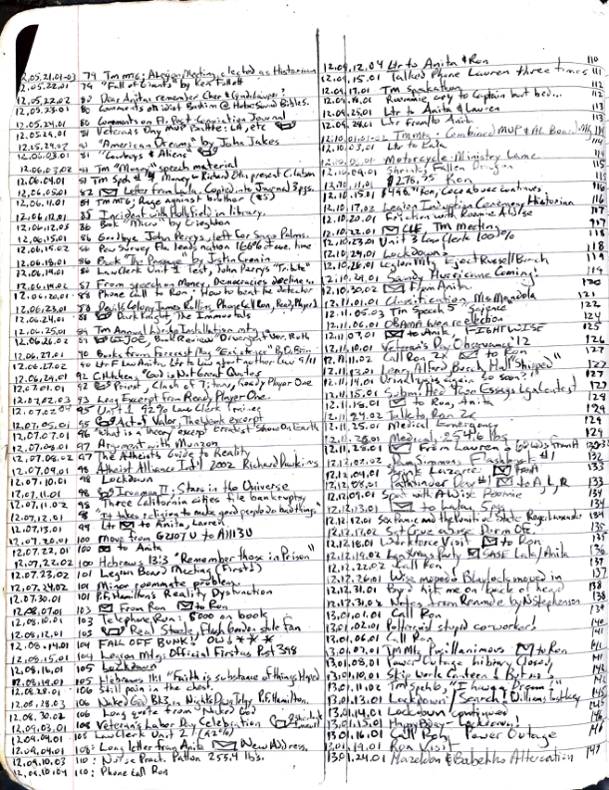

Here are the extracted texts from the provided images:  
  
**Image 1:**  
  
```  
Composition  
college ruled  
Kenneth Courtney   
Res. Entries: Nov 2011 - Sept 2013  
```  
  
**Image 2:**  
  
```  
Monday | Tuesday | Wednesday | Thursday | Friday  
  
Mutual (772) 579-3705 (see pg 13)  
  
Ohio Interstate Compact Office  
1-866-472-6446 Gail Burns  
  
Securus Phone Account 800-844-6591  
  
TIME:  
8 a.m. Pacific  
9 a.m. Mountain  
10 a.m. Central  
11 a.m. Eastern  
  
New York | Los Angeles | London | Moscow | Tokyo | Beijing  
```  
  
**Image 3:**  
  
```  
Kenneth Courtney  
  
CONTENTS  
  
11.10.06.01 Entry SL 3  
11.10.06.02 "Forever" + Jonathan Moran 4  
11.10.06.03 Fish Story by M Clarke 6  
11.10.06.04 Stephen Bayley 7  
11.10.07.01 Race Class Doing Time 9  
11.10.07.02 Remnants 11  
11.10.07.03 Hello Lancers 12  
11.10.08.01 Jonathan & Bree S.A. 12  
11.11.03.01 I'm Michael 19  
11.11.04.01 Accountants & Atrocities 20  
11.11.09.01 Poetry and Prayer 'Cujo' 22  
11.11.20.01 Theresa Blasphemy 24  
11.11.03.02 Talk on Empires 25  
11.11.01.01 Teenager's Walk (JFPH) 26  
11.11.04.04 I'm Torn 27  
11.11.10.01 Latins & Comics Wed+ Thu 28  
11.11.12.01 Cheers (Life) for Health 29  
11.11.12.01 SAT Sherlock Holmes 29  
11.11.20.01 College Blessings 30  
11.11.27.01 Washer's Gone 31  
11.11.28.01 Influences (Education) 31  
11.11.30.01 Immerson 32  
11.11.30.02 Teen Comedians 32  
11.12.02.01 Dickerson’s A*** S*** 32  
11.12.06.01 I am Robert 34  
11.11.10.01 Tony Robbins & A.J. Ayer 34  
11.11.28.01 Grandmother's Lazor 34  
11.11.18.01 Bonafacio Puppy's 35  
11.11.11.01 One and Only Grandpa 36  
11.11.30.01 Purolator 37  
11.11.15.01 It could happen 37  
11.11.15.01 Deborah's Lonely Gasp 38  
11.11.14.01 Real Estate 38  
11.11.30.01 Baseball Comparisons 39  
11.11.15.01 My Birthday 39  
11.12.05.01 Numbers Game 40  
11.11.11.01 Steve's Tech Talk 41  
11.12.04.01 I'm Meeting 42  
11.12.04.01 Facebook Zuckerberg 41  
11.12.07.01 My Spy Scope Ops 4  
11.12.12.01 Dennis - I'm Here! Jail Tidabra 41  
11.12.08.01 G.P.* Entertainment 43  
11.12.08.01 G.P.scwo music 43  
11.12.19.01 I'm Infamous 41  
11.12.05.01 Dennis & Me Fulson Family Book 44  
11.12.08.01 Francis (West Wing) Dialogue 44  
11.12.15.01 News Too High Emit Barronate 45  
11.12.15.01 Brett Kavanaugh 45  
11.12.19.01 Macaroo 46  
11.12.20.01 Four Pictures 46  
11.12.20.01 Dilemma in Winterton 47  
11.12.22.01 Open a casino 47  
11.12.22.01 TD Thomas Koch Englishissed 48  
11.12.20.01 Politician Bros 48  
11.12.23.01 Sci-Fi Quotes 49  
11.12.25.01 Holding Coffee (Kozak) Patent 49  
12.01.04.01 Hello from Court 49  
12.01.08.01 Mysteries of Attachments 50  
12.01.14.01 Francenlpark 52  
12.01.21.01 Genes G.R 52  
12.01.21.02 Pelley Carmos M 53  
12.01.26.01 Kevin and Prison 53  
12.01.21.01 Who's Dominant 54  
12.02.01.01 Looks 55  
12.02.04.01 Tim Inc. Big Funny Gilmans/Offsang 54  
12.02.24.01 M.-Raymond Aaron/Jona 54  
12.02.26.01 Living God's Paper/Newspaper 55  
12.02.22.01 Volt I.J.A. Kierant Ricesky PIE 54  
12.02.29.01 3 x More PIE 56  
12.03.26.01 Marathon 69  
12.02.28.01 Unknown 56  
12.12.18.01 Guess and Days 57  
12.12.18.01 Poetry C 58  
11.11.28.01 Letters JESUS & POEM 59  
12.03.15.01 Newspaper Infamous Army 58  
12.03.22.01 Need and Participating Paragraph 59  
12.12.20.2012 Heroes Holytown 59  
12.02.22.01 How to Write a Story 60  
12.12.25.01 Case 60  
12.12.21.01 50 Millions 60  
12.12.21.01 Spikes into Rebar Prere 60  
12.11.25.01 I'm Mutesa 61  
12.12.02.01 Nurse Williams Bello Long Arms 61  
12.12.15.01 (Maint) LT - WP Harris Special 62  
12.12.15.01 Love from Px! First Kiss (X Ray) 61  
12.03.04.01 Teenage Pooh 62  
12.12.18.01 Drafts R Euclid Karl Fust 62  
12.01.25.01 Shopping Mall and Mevnet 63  
12.02.28.01 Nurse 62  
12.12.17.01 Tim Speculates 64  
12.11.17.01 Spin & Move+ Live 64  
12.12.20.01 I Love You 64   
12.04.01.01 Cheating Me and 64  
12.11.25.01 Haitian Talk 64  
12.12.22.01 Full Postmanther Funderis 65  
12.11.21.01 My Speculations 66  
12.01.24.2012 Plus Time+ Anatomy 65  
12.04.19.01 "Sino Blue" Talks Movie 68  
12.01.21.01 Case 66  
12.11.07.01 Find Panama 66  
12.11.08.01 Liza and Math Rush 66  
12.11.01.01 Tag Sci-Fi Upward 66  
12.12.12.01 Song 67  
12.04.26.01 PM Address 69  
12.03.01.01 Background 69  
11.12.01.01 PIA from Ex 62670. " I.G. META 67  
12.03.22.01 PIA Fathers? GHOST PROTOCOL 75  
12.03.13.05 TM/British only one question rec'd 75  
12.03.17.01 Home - Prison 74  
12.12.24.01 John's Wedding Kevin Coleman 75  
12.12.25.01 ' Case from Enteral 7 6  
12.12.25.01 KG Miz Theater New Year's Eve 77  
12.11.17.01 Funny Jokes 73  
12.11.18.01 Kevin's eve - Quietenest Level Bus. 68  
12.01.25.01 L.I. - MAG Wood impressed 60   
12.12.20.01 Tim Speculates 68  
12.10.01.01 Write me into an Escape 63  
  
12.12.05

## Reflections Vol I Nov 11-Sep 13.pdf - Page 5

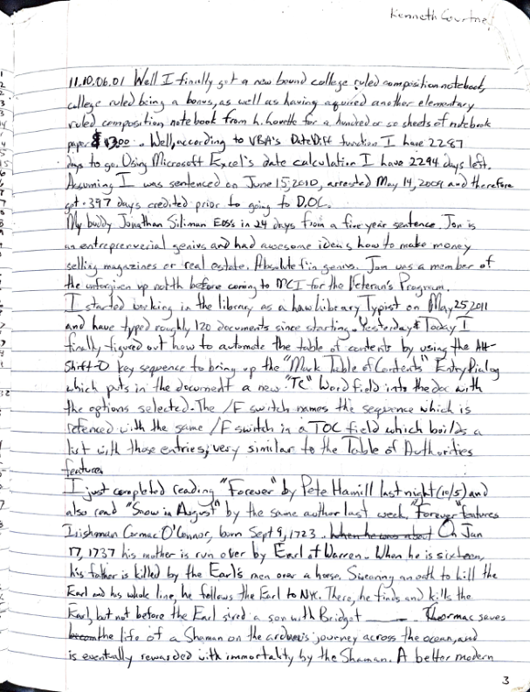

Here are the extracted texts from the provided images:  
  
**Image 1:**  
  
```  
Composition  
college ruled  
Kenneth Courtney   
Res. Entries: Nov 2011 - Sept 2013  
```  
  
**Image 2:**  
  
```  
Monday | Tuesday | Wednesday | Thursday | Friday  
  
Mutual (772) 579-3705 (see pg 13)  
  
Ohio Interstate Compact Office  
1-866-472-6446 Gail Burns  
  
Securus Phone Account 800-844-6591  
  
TIME:  
8 a.m. Pacific  
9 a.m. Mountain  
10 a.m. Central  
11 a.m. Eastern  
  
New York | Los Angeles | London | Moscow | Tokyo | Beijing  
```  
  
**Image 3:**  
  
```  
Kenneth Courtney  
  
CONTENTS  
  
11.10.06.01 Entry SL 3  
11.10.06.02 "Forever" + Jonathan Moran 4  
11.10.06.03 Fish Story by M Clarke 6  
11.10.06.04 Stephen Bayley 7  
11.10.07.01 Race Class Doing Time 9  
11.10.07.02 Remnants 11  
11.10.07.03 Hello Lancers 12  
11.10.08.01 Jonathan & Bree S.A. 12  
11.11.03.01 I'm Michael 19  
11.11.04.01 Accountants & Atrocities 20  
11.11.09.01 Poetry and Prayer 'Cujo' 22  
11.11.20.01 Theresa Blasphemy 24  
11.11.03.02 Talk on Empires 25  
11.11.01.01 Teenager's Walk (JFPH) 26  
11.11.04.04 I'm Torn 27  
11.11.10.01 Latins & Comics Wed+ Thu 28  
11.11.12.01 Cheers (Life) for Health 29  
11.11.12.01 SAT Sherlock Holmes 29  
11.11.20.01 College Blessings 30  
11.11.27.01 Washer's Gone 31  
11.11.28.01 Influences (Education) 31  
11.11.30.01 Immerson 32  
11.11.30.02 Teen Comedians 32  
11.12.02.01 Dickerson’s A*** S*** 32  
11.12.06.01 I am Robert 34  
11.11.10.01 Tony Robbins & A.J. Ayer 34  
11.11.28.01 Grandmother's Lazor 34  
11.11.18.01 Bonafacio Puppy's 35  
11.11.11.01 One and Only Grandpa 36  
11.11.30.01 Purolator 37  
11.11.15.01 It could happen 37  
11.11.15.01 Deborah's Lonely Gasp 38  
11.11.14.01 Real Estate 38  
11.11.30.01 Baseball Comparisons 39  
11.11.15.01 My Birthday 39  
11.12.05.01 Numbers Game 40  
11.11.11.01 Steve's Tech Talk 41  
11.12.04.01 I'm Meeting 42  
11.12.04.01 Facebook Zuckerberg 41  
11.12.07.01 My Spy Scope Ops 4  
11.12.12.01 Dennis - I'm Here! Jail Tidabra 41  
11.12.08.01 G.P.* Entertainment 43  
11.12.08.01 G.P.scwo music 43  
11.12.19.01 I'm Infamous 41  
11.12.05.01 Dennis & Me Fulson Family Book 44  
11.12.08.01 Francis (West Wing) Dialogue 44  
11.12.15.01 News Too High Emit Barronate 45  
11.12.15.01 Brett Kavanaugh 45  
11.12.19.01 Macaroo 46  
11.12.20.01 Four Pictures 46  
11.12.20.01 Dilemma in Winterton 47  
11.12.22.01 Open a casino 47  
11.12.22.01 TD Thomas Koch Englishissed 48  
11.12.20.01 Politician Bros 48  
11.12.23.01 Sci-Fi Quotes 49  
11.12.25.01 Holding Coffee (Kozak) Patent 49  
12.01.04.01 Hello from Court 49  
12.01.08.01 Mysteries of Attachments 50  
12.01.14.01 Francenlpark 52  
12.01.21.01 Genes G.R 52  
12.01.21.02 Pelley Carmos M 53  
12.01.26.01 Kevin and Prison 53  
12.01.21.01 Who's Dominant 54  
12.02.01.01 Looks 55  
12.02.04.01 Tim Inc. Big Funny Gilmans/Offsang 54  
12.02.24.01 M.-Raymond Aaron/Jona 54  
12.02.26.01 Living God's Paper/Newspaper 55  
12.02.22.01 Volt I.J.A. Kierant Ricesky PIE 54  
12.02.29.01 3 x More PIE 56  
12.03.26.01 Marathon 69  
12.02.28.01 Unknown 56  
12.12.18.01 Guess and Days 57  
12.12.18.01 Poetry C 58  
11.11.28.01 Letters JESUS & POEM 59  
12.03.15.01 Newspaper Infamous Army 58  
12.03.22.01 Need and Participating Paragraph 59  
12.12.20.2012 Heroes Holytown 59  
12.02.22.01 How to Write a Story 60  
12.12.25.01 Case 60  
12.12.21.01 50 Millions 60  
12.12.21.01 Spikes into Rebar Prere 60  
12.11.25.01 I'm Mutesa 61  
12.12.02.01 Nurse Williams Bello Long Arms 61  
12.12.15.01 (Maint) LT - WP Harris Special 62  
12.12.15.01 Love from Px! First Kiss (X Ray) 61  
12.03.04.01 Teenage Pooh 62  
12.12.18.01 Drafts R Euclid Karl Fust 62  
12.01.25.01 Shopping Mall and Mevnet 63  
12.02.28.01 Nurse 62  
12.12.17.01 Tim Speculates 64  
12.11.17.01 Spin & Move+ Live 64  
12.12.20.01 I Love You 64   
12.04.01.01 Cheating Me and 64  
12.11.25.01 Haitian Talk 64  
12.12.22.01 Full Postmanther Funderis 65  
12.11.21.01 My Speculations 66  
12.01.24.2012 Plus Time+ Anatomy 65  
12.04.19.01 "Sino Blue" Talks Movie 68  
12.01.21.01 Case 66  
12.11.07.01 Find Panama 66  
12.11.08.01 Liza and Math Rush 66  
12.11.01.01 Tag Sci-Fi Upward 66  
12.12.12.01 Song 67  
12.04.26.01 PM Address 69  
12.03.01.01 Background 69  
11.12.01.01 PIA from Ex 62670. " I.G. META 67  
12.03.22.01 PIA Fathers? GHOST PROTOCOL 75  
12.03.13.05 TM/British only one question rec'd 75  
12.03.17.01 Home - Prison 74  
12.12.24.01 John's Wedding Kevin Coleman 75  
12.12.25.01 ' Case from Enteral 7 6  
12.12.25.01 KG Miz Theater New Year's Eve 77  
12.11.17.01 Funny Jokes 73  
12.11.18.01 Kevin's eve - Quietenest Level Bus. 68  
12.01.25.01 L.I. - MAG Wood impressed 60   
12.12.20.01 Tim Speculates 68  
12.10.01.01 Write me into an Escape 63  
  
12.12.05

## Reflections Vol I Nov 11-Sep 13.pdf - Page 6

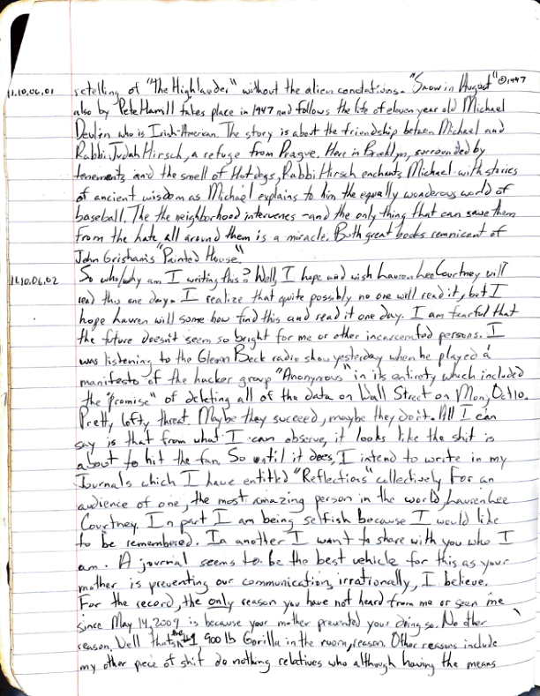

### Image 1  
**11.10.06.01**  
  
Retelling of “The Highlands” without the alien conditions. “Snow in August” also by Pete Hamill takes place in 1947 and follows the life of eleven-year-old Michael Devlin, who is Irish-American. The story is about the friendship between Michael and Rabbi Judah Hirsch, a refugee from Prague. Here in Brooklyn, surrounded by tenements and the smell of Hot dogs, Rabbi Hirsch enchants Michael with stories of ancient wisdom as Michael explains to him the equally wondrous world of baseball. The neighborhood intervenes and the only thing that can save them from the hate all around them is a miracle. Both great books reminiscent of John Grisham’s “Painted House.”  
  
**11.10.06.02**  
  
So why am I writing this? Well, I hope and wish Laurence and Courtney will see this one day. I realize that quite possibly no one will read it, but I hope Lauren will somehow find this and read it one day. I am fearful that the future doesn’t seem so bright for me or other incarcerated persons. I was listening to the Glenn Beck radio show yesterday when he played a manifesto of the hacker group “Anonymous” in its entirety which included the “promise” of deleting all of the data on Wall Street on Mon, Oct 10. Pretty lofty threat! Maybe they succeeded, maybe they didn’t. All I can say is that from what I can observe, it looks like the shit is about to hit the fan. So until it does, I intend to write in my journals which I have entitled “Reflections collected by (for an audience of) one, the most amazing person in the world Lauren Courtney (In part I am being selfish because I would like to be remembered). In another, I want to share with you who I am. A journal seems to be the best vehicle for this as your mother is preempting our communicating, irrationally I'd believe.   
  
For the record, the only reason you have not heard from me or seen me since May 14, 2009, is because your mother prevented you. No other reason. Well, I tried, 400 lbs Gorilla in the room person. Other reasons include any other piece of shit I do nothing relatives who although knowing the means and the desire for your well-being pussyfooted around and did nothing when they should have acted. But first and foremost, the #1 reason you haven’t seen or heard from me is Aunt Michelle Lee Norton Courtney Woods. Am I bitter? You’re damn right I am. I refuse to believe you don’t love me or care about me. I believe you are in a bad situation. It takes a considerable amount of effort and ingenuity to connect a pen to paper, put it in an envelope, put an address on that envelope, put a stamp on that envelope, and then deposit that envelope in a mailbox. You may recall the number of times the electricity or water was cut off in the house. You may recall the number of times we were cut off of the home.  
  
  
### Image 2  
**11.10.06.02 (continued)**  
  
- The only reason why that happened was I was incapable of such superhuman feats as putting ink on a check, putting the check in an envelope, putting an address on the envelope, and putting a stamp on that envelope and putting it in the mail.  
  
I wrote you seven separate letters from March to July. In August, I asked my buddy to have his wife find out what was going on, specifically why I hadn’t heard from you or your mother. I see Dr. Martin in January when I was in Texas (a story for another day), and at that time, she told me that she still loves me and thought about me every day (several times). So of course I still love your mom and always will, but that doesn’t mean I can’t be really pissed at her for being such a bitch. Speaking of love, the opposite of love is INDIFFERENCE. Hate and Love are intertwined. So some days I feel like I hate your mom, you can think of it in the context that as I have A great Betrayal. Your mom betrayed me three times, and I have forgiven her. Even in my last letter, I stated simply that I will always love both of you. And of course, this whole situation sucks for you. I mean that I am sorry a thousand times. But I can honestly say I never thought in a million years I would end up ripped from life like I have been. As Tony Ellison always used to say, Fair is a place where you ride the rides. This whole goddamn situation hasn’t been fair. I am sorry. So anyway, my buddy’s wife called; I think in August or so, and she was verbally accosted by your loving mother, stepfather in a tag team match from hell. I wrote your great-aunt and uncle (who at least visit me although it has done nothing else) to say to your mom that she could go fuck herself for all I care. So, anyway, I was reading the Oct 3 Time Magazine when I happened (read) upon an article about- Tea Partiers decrying the horrible state of a society that would actually pay Disability Benefits (SSD Social Security Disability) of families with children diagnosed as ADD/ADHD (Attention Deficit Hyperactivity Disorder). As I wrote in the letter to your mom, who cares whether ADHD exists or not, money is money man. Times are tough and if you can get more money from our tyrannical government then do it!  
  
Well, I have burned up nearly four pages of this Reflection and I haven’t even scratched the surface. Lauren, I think of you many times every day. I will always love you and I am proud of you and miss you. I wish I could see you and hear from you. Well, I just get a 21-page Initial Brief to work on. I’ll talk to you soon.  
  
**11.10.06.03**  
  
Well, I finally got the book “Firstborn” by A.C. Clarke & Stephen Baxter today. As it turns out, Firstborn is the last book of the Time Odyssey trilogy. From the book’s cover: their first act into the Discontinuity, in which Earth was carved into sections from different eras of history, resulted in a patchwork world, dominated by Mankind’s inheritors, including such notables as Alexander the Great, Genghis Khan, and United Nations peacekeeper Bisesa Dutt. For reasons unknown to her, Bisesa entered into communication with an alien artifact of inscrutable purpose and godlike power that eventually returned her to Earth. There, she played an instrumental role in humanity’s race against time to stop a doomsday event: a massive solar storm triggered by the alien Firstborn designed to eradicate all life from the planet. That fate was averted at an inconceivable price. Now, 27 yrs later, the Firstborn are back. This time they aren’t pulling punches; they have sent “quantum” bomb speeding towards Earth. It is a device that human scientists can barely comprehend, that cannot be stopped or destroyed - a bomb that will obliterate the world. Bisesa’s desperate quest for answers sends her first to Mars and then to Mir, which is itself threatened with extinction. The end seems inevitable, but as shocking new insights emerge into the nature of the Firstborn and their chilling plans for humanity, an unexpected ally appears from light-years away.  
Well, that was quite the mouthful. Sometimes the best way to explain something as complicated as a SciFi Space Opera trilogy is its own book jacket from the third book of the trilogy no less.   
  
I am using an Office Depot generic pen to write this. It is the second of four identical pens I have been given each month since working library. I was devastated when I lost the first but quite relieved when I got the one I am writing with now about a week later. Then, I eventually got two more which I fortunately haven’t lost yet. I use the 2nd OD pen so much I splintered its plastic tip. So I put the 2nd's disposable ink assembly into the 3rd (or 4th? From what I understand) this will be the last month of the OD pens, then we will probably get BIC pens with bigger points. I’ll probably find someone to sell one of these OD pens because I love the fine point which lets me write so tiny. It sure is nice to have this notebook. (93 pages left to fill, hopefully with substantially more interesting information.)  
  
**11.10.07.01**  
  
Chess class goes very productive today! My instructor Humberto Romeo Romero has been down for 7 ½ on a 15-year sentence and gets out in March of 2018 two yrs or so from now. I just call him Maestro for short. Maestro is a Mexican doctor, OB/GYN and he says a surgeon, and was a chess grand master at age 12 or 13 in Cuba. Maestro has been a good friend since last November when I arrived at Martin. Today’s game focused on the Sicilian defense 2 Nc6 and I believe I learned quite a few new principles (principals?) not previously known. One principle, known as Opposition, wherein if you and your opponent’s say your opponent’s pawn to a single pawn, unless your opponent’s King is on the sixth rank ahead of his pawn, the game will always end in a stalemate if the King is always moved mirroring the opponent’s King. Opposition. Other principles cover by Never move same piece 2x in opening. Opening is defined as the development of every back

## Reflections Vol I Nov 11-Sep 13.pdf - Page 7

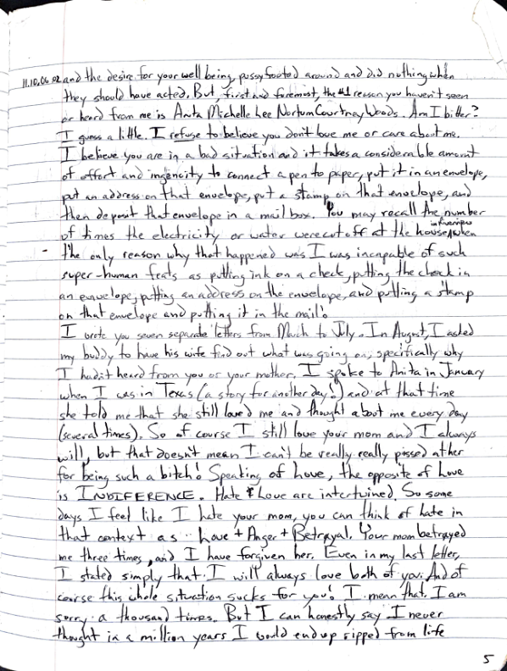

### Image 1  
**11.10.06.01**  
  
Retelling of “The Highlands” without the alien conditions. “Snow in August” also by Pete Hamill takes place in 1947 and follows the life of eleven-year-old Michael Devlin, who is Irish-American. The story is about the friendship between Michael and Rabbi Judah Hirsch, a refugee from Prague. Here in Brooklyn, surrounded by tenements and the smell of Hot dogs, Rabbi Hirsch enchants Michael with stories of ancient wisdom as Michael explains to him the equally wondrous world of baseball. The neighborhood intervenes and the only thing that can save them from the hate all around them is a miracle. Both great books reminiscent of John Grisham’s “Painted House.”  
  
**11.10.06.02**  
  
So why am I writing this? Well, I hope and wish Laurence and Courtney will see this one day. I realize that quite possibly no one will read it, but I hope Lauren will somehow find this and read it one day. I am fearful that the future doesn’t seem so bright for me or other incarcerated persons. I was listening to the Glenn Beck radio show yesterday when he played a manifesto of the hacker group “Anonymous” in its entirety which included the “promise” of deleting all of the data on Wall Street on Mon, Oct 10. Pretty lofty threat! Maybe they succeeded, maybe they didn’t. All I can say is that from what I can observe, it looks like the shit is about to hit the fan. So until it does, I intend to write in my journals which I have entitled “Reflections collected by (for an audience of) one, the most amazing person in the world Lauren Courtney (In part I am being selfish because I would like to be remembered). In another, I want to share with you who I am. A journal seems to be the best vehicle for this as your mother is preempting our communicating, irrationally I'd believe.   
  
For the record, the only reason you have not heard from me or seen me since May 14, 2009, is because your mother prevented you. No other reason. Well, I tried, 400 lbs Gorilla in the room person. Other reasons include any other piece of shit I do nothing relatives who although knowing the means and the desire for your well-being pussyfooted around and did nothing when they should have acted. But first and foremost, the #1 reason you haven’t seen or heard from me is Aunt Michelle Lee Norton Courtney Woods. Am I bitter? You’re damn right I am. I refuse to believe you don’t love me or care about me. I believe you are in a bad situation. It takes a considerable amount of effort and ingenuity to connect a pen to paper, put it in an envelope, put an address on that envelope, put a stamp on that envelope, and then deposit that envelope in a mailbox. You may recall the number of times the electricity or water was cut off in the house. You may recall the number of times we were cut off of the home.  
  
  
### Image 2  
**11.10.06.02 (continued)**  
  
- The only reason why that happened was I was incapable of such superhuman feats as putting ink on a check, putting the check in an envelope, putting an address on the envelope, and putting a stamp on that envelope and putting it in the mail.  
  
I wrote you seven separate letters from March to July. In August, I asked my buddy to have his wife find out what was going on, specifically why I hadn’t heard from you or your mother. I see Dr. Martin in January when I was in Texas (a story for another day), and at that time, she told me that she still loves me and thought about me every day (several times). So of course I still love your mom and always will, but that doesn’t mean I can’t be really pissed at her for being such a bitch. Speaking of love, the opposite of love is INDIFFERENCE. Hate and Love are intertwined. So some days I feel like I hate your mom, you can think of it in the context that as I have A great Betrayal. Your mom betrayed me three times, and I have forgiven her. Even in my last letter, I stated simply that I will always love both of you. And of course, this whole situation sucks for you. I mean that I am sorry a thousand times. But I can honestly say I never thought in a million years I would end up ripped from life like I have been. As Tony Ellison always used to say, Fair is a place where you ride the rides. This whole goddamn situation hasn’t been fair. I am sorry. So anyway, my buddy’s wife called; I think in August or so, and she was verbally accosted by your loving mother, stepfather in a tag team match from hell. I wrote your great-aunt and uncle (who at least visit me although it has done nothing else) to say to your mom that she could go fuck herself for all I care. So, anyway, I was reading the Oct 3 Time Magazine when I happened (read) upon an article about- Tea Partiers decrying the horrible state of a society that would actually pay Disability Benefits (SSD Social Security Disability) of families with children diagnosed as ADD/ADHD (Attention Deficit Hyperactivity Disorder). As I wrote in the letter to your mom, who cares whether ADHD exists or not, money is money man. Times are tough and if you can get more money from our tyrannical government then do it!  
  
Well, I have burned up nearly four pages of this Reflection and I haven’t even scratched the surface. Lauren, I think of you many times every day. I will always love you and I am proud of you and miss you. I wish I could see you and hear from you. Well, I just get a 21-page Initial Brief to work on. I’ll talk to you soon.  
  
**11.10.06.03**  
  
Well, I finally got the book “Firstborn” by A.C. Clarke & Stephen Baxter today. As it turns out, Firstborn is the last book of the Time Odyssey trilogy. From the book’s cover: their first act into the Discontinuity, in which Earth was carved into sections from different eras of history, resulted in a patchwork world, dominated by Mankind’s inheritors, including such notables as Alexander the Great, Genghis Khan, and United Nations peacekeeper Bisesa Dutt. For reasons unknown to her, Bisesa entered into communication with an alien artifact of inscrutable purpose and godlike power that eventually returned her to Earth. There, she played an instrumental role in humanity’s race against time to stop a doomsday event: a massive solar storm triggered by the alien Firstborn designed to eradicate all life from the planet. That fate was averted at an inconceivable price. Now, 27 yrs later, the Firstborn are back. This time they aren’t pulling punches; they have sent “quantum” bomb speeding towards Earth. It is a device that human scientists can barely comprehend, that cannot be stopped or destroyed - a bomb that will obliterate the world. Bisesa’s desperate quest for answers sends her first to Mars and then to Mir, which is itself threatened with extinction. The end seems inevitable, but as shocking new insights emerge into the nature of the Firstborn and their chilling plans for humanity, an unexpected ally appears from light-years away.  
Well, that was quite the mouthful. Sometimes the best way to explain something as complicated as a SciFi Space Opera trilogy is its own book jacket from the third book of the trilogy no less.   
  
I am using an Office Depot generic pen to write this. It is the second of four identical pens I have been given each month since working library. I was devastated when I lost the first but quite relieved when I got the one I am writing with now about a week later. Then, I eventually got two more which I fortunately haven’t lost yet. I use the 2nd OD pen so much I splintered its plastic tip. So I put the 2nd's disposable ink assembly into the 3rd (or 4th? From what I understand) this will be the last month of the OD pens, then we will probably get BIC pens with bigger points. I’ll probably find someone to sell one of these OD pens because I love the fine point which lets me write so tiny. It sure is nice to have this notebook. (93 pages left to fill, hopefully with substantially more interesting information.)  
  
**11.10.07.01**  
  
Chess class goes very productive today! My instructor Humberto Romeo Romero has been down for 7 ½ on a 15-year sentence and gets out in March of 2018 two yrs or so from now. I just call him Maestro for short. Maestro is a Mexican doctor, OB/GYN and he says a surgeon, and was a chess grand master at age 12 or 13 in Cuba. Maestro has been a good friend since last November when I arrived at Martin. Today’s game focused on the Sicilian defense 2 Nc6 and I believe I learned quite a few new principles (principals?) not previously known. One principle, known as Opposition, wherein if you and your opponent’s say your opponent’s pawn to a single pawn, unless your opponent’s King is on the sixth rank ahead of his pawn, the game will always end in a stalemate if the King is always moved mirroring the opponent’s King. Opposition. Other principles cover by Never move same piece 2x in opening. Opening is defined as the development of every back

## Reflections Vol I Nov 11-Sep 13.pdf - Page 8

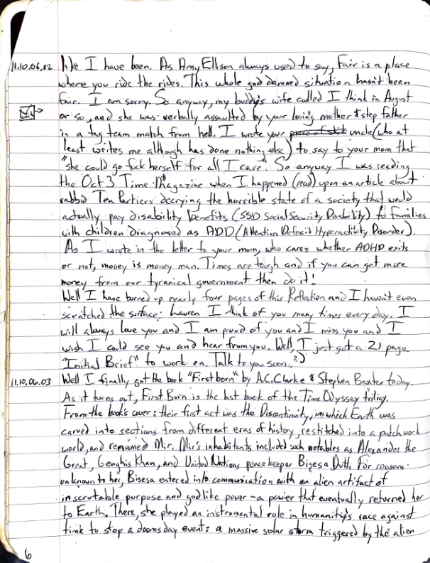

### Image 1  
**11.10.06.01**  
  
Retelling of “The Highlands” without the alien conditions. “Snow in August” also by Pete Hamill takes place in 1947 and follows the life of eleven-year-old Michael Devlin, who is Irish-American. The story is about the friendship between Michael and Rabbi Judah Hirsch, a refugee from Prague. Here in Brooklyn, surrounded by tenements and the smell of Hot dogs, Rabbi Hirsch enchants Michael with stories of ancient wisdom as Michael explains to him the equally wondrous world of baseball. The neighborhood intervenes and the only thing that can save them from the hate all around them is a miracle. Both great books reminiscent of John Grisham’s “Painted House.”  
  
**11.10.06.02**  
  
So why am I writing this? Well, I hope and wish Laurence and Courtney will see this one day. I realize that quite possibly no one will read it, but I hope Lauren will somehow find this and read it one day. I am fearful that the future doesn’t seem so bright for me or other incarcerated persons. I was listening to the Glenn Beck radio show yesterday when he played a manifesto of the hacker group “Anonymous” in its entirety which included the “promise” of deleting all of the data on Wall Street on Mon, Oct 10. Pretty lofty threat! Maybe they succeeded, maybe they didn’t. All I can say is that from what I can observe, it looks like the shit is about to hit the fan. So until it does, I intend to write in my journals which I have entitled “Reflections collected by (for an audience of) one, the most amazing person in the world Lauren Courtney (In part I am being selfish because I would like to be remembered). In another, I want to share with you who I am. A journal seems to be the best vehicle for this as your mother is preempting our communicating, irrationally I'd believe.   
  
For the record, the only reason you have not heard from me or seen me since May 14, 2009, is because your mother prevented you. No other reason. Well, I tried, 400 lbs Gorilla in the room person. Other reasons include any other piece of shit I do nothing relatives who although knowing the means and the desire for your well-being pussyfooted around and did nothing when they should have acted. But first and foremost, the #1 reason you haven’t seen or heard from me is Aunt Michelle Lee Norton Courtney Woods. Am I bitter? You’re damn right I am. I refuse to believe you don’t love me or care about me. I believe you are in a bad situation. It takes a considerable amount of effort and ingenuity to connect a pen to paper, put it in an envelope, put an address on that envelope, put a stamp on that envelope, and then deposit that envelope in a mailbox. You may recall the number of times the electricity or water was cut off in the house. You may recall the number of times we were cut off of the home.  
  
  
### Image 2  
**11.10.06.02 (continued)**  
  
- The only reason why that happened was I was incapable of such superhuman feats as putting ink on a check, putting the check in an envelope, putting an address on the envelope, and putting a stamp on that envelope and putting it in the mail.  
  
I wrote you seven separate letters from March to July. In August, I asked my buddy to have his wife find out what was going on, specifically why I hadn’t heard from you or your mother. I see Dr. Martin in January when I was in Texas (a story for another day), and at that time, she told me that she still loves me and thought about me every day (several times). So of course I still love your mom and always will, but that doesn’t mean I can’t be really pissed at her for being such a bitch. Speaking of love, the opposite of love is INDIFFERENCE. Hate and Love are intertwined. So some days I feel like I hate your mom, you can think of it in the context that as I have A great Betrayal. Your mom betrayed me three times, and I have forgiven her. Even in my last letter, I stated simply that I will always love both of you. And of course, this whole situation sucks for you. I mean that I am sorry a thousand times. But I can honestly say I never thought in a million years I would end up ripped from life like I have been. As Tony Ellison always used to say, Fair is a place where you ride the rides. This whole goddamn situation hasn’t been fair. I am sorry. So anyway, my buddy’s wife called; I think in August or so, and she was verbally accosted by your loving mother, stepfather in a tag team match from hell. I wrote your great-aunt and uncle (who at least visit me although it has done nothing else) to say to your mom that she could go fuck herself for all I care. So, anyway, I was reading the Oct 3 Time Magazine when I happened (read) upon an article about- Tea Partiers decrying the horrible state of a society that would actually pay Disability Benefits (SSD Social Security Disability) of families with children diagnosed as ADD/ADHD (Attention Deficit Hyperactivity Disorder). As I wrote in the letter to your mom, who cares whether ADHD exists or not, money is money man. Times are tough and if you can get more money from our tyrannical government then do it!  
  
Well, I have burned up nearly four pages of this Reflection and I haven’t even scratched the surface. Lauren, I think of you many times every day. I will always love you and I am proud of you and miss you. I wish I could see you and hear from you. Well, I just get a 21-page Initial Brief to work on. I’ll talk to you soon.  
  
**11.10.06.03**  
  
Well, I finally got the book “Firstborn” by A.C. Clarke & Stephen Baxter today. As it turns out, Firstborn is the last book of the Time Odyssey trilogy. From the book’s cover: their first act into the Discontinuity, in which Earth was carved into sections from different eras of history, resulted in a patchwork world, dominated by Mankind’s inheritors, including such notables as Alexander the Great, Genghis Khan, and United Nations peacekeeper Bisesa Dutt. For reasons unknown to her, Bisesa entered into communication with an alien artifact of inscrutable purpose and godlike power that eventually returned her to Earth. There, she played an instrumental role in humanity’s race against time to stop a doomsday event: a massive solar storm triggered by the alien Firstborn designed to eradicate all life from the planet. That fate was averted at an inconceivable price. Now, 27 yrs later, the Firstborn are back. This time they aren’t pulling punches; they have sent “quantum” bomb speeding towards Earth. It is a device that human scientists can barely comprehend, that cannot be stopped or destroyed - a bomb that will obliterate the world. Bisesa’s desperate quest for answers sends her first to Mars and then to Mir, which is itself threatened with extinction. The end seems inevitable, but as shocking new insights emerge into the nature of the Firstborn and their chilling plans for humanity, an unexpected ally appears from light-years away.  
Well, that was quite the mouthful. Sometimes the best way to explain something as complicated as a SciFi Space Opera trilogy is its own book jacket from the third book of the trilogy no less.   
  
I am using an Office Depot generic pen to write this. It is the second of four identical pens I have been given each month since working library. I was devastated when I lost the first but quite relieved when I got the one I am writing with now about a week later. Then, I eventually got two more which I fortunately haven’t lost yet. I use the 2nd OD pen so much I splintered its plastic tip. So I put the 2nd's disposable ink assembly into the 3rd (or 4th? From what I understand) this will be the last month of the OD pens, then we will probably get BIC pens with bigger points. I’ll probably find someone to sell one of these OD pens because I love the fine point which lets me write so tiny. It sure is nice to have this notebook. (93 pages left to fill, hopefully with substantially more interesting information.)  
  
**11.10.07.01**  
  
Chess class goes very productive today! My instructor Humberto Romeo Romero has been down for 7 ½ on a 15-year sentence and gets out in March of 2018 two yrs or so from now. I just call him Maestro for short. Maestro is a Mexican doctor, OB/GYN and he says a surgeon, and was a chess grand master at age 12 or 13 in Cuba. Maestro has been a good friend since last November when I arrived at Martin. Today’s game focused on the Sicilian defense 2 Nc6 and I believe I learned quite a few new principles (principals?) not previously known. One principle, known as Opposition, wherein if you and your opponent’s say your opponent’s pawn to a single pawn, unless your opponent’s King is on the sixth rank ahead of his pawn, the game will always end in a stalemate if the King is always moved mirroring the opponent’s King. Opposition. Other principles cover by Never move same piece 2x in opening. Opening is defined as the development of every back

## Reflections Vol I Nov 11-Sep 13.pdf - Page 9

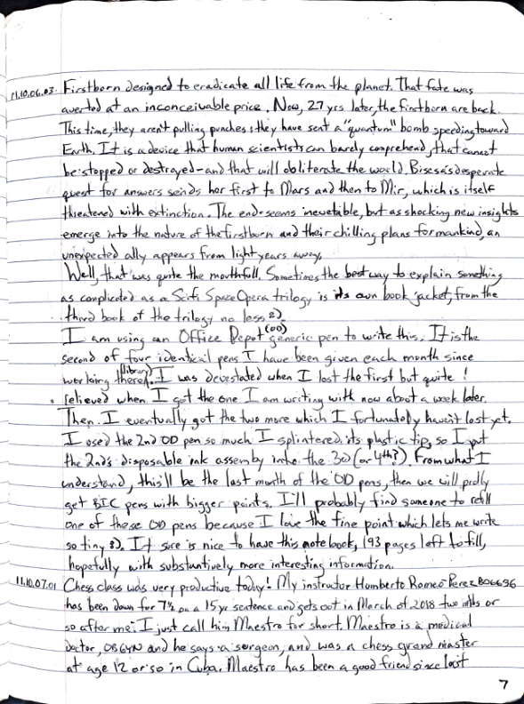

### Image 1  
**11.10.06.01**  
  
Retelling of “The Highlands” without the alien conditions. “Snow in August” also by Pete Hamill takes place in 1947 and follows the life of eleven-year-old Michael Devlin, who is Irish-American. The story is about the friendship between Michael and Rabbi Judah Hirsch, a refugee from Prague. Here in Brooklyn, surrounded by tenements and the smell of Hot dogs, Rabbi Hirsch enchants Michael with stories of ancient wisdom as Michael explains to him the equally wondrous world of baseball. The neighborhood intervenes and the only thing that can save them from the hate all around them is a miracle. Both great books reminiscent of John Grisham’s “Painted House.”  
  
**11.10.06.02**  
  
So why am I writing this? Well, I hope and wish Laurence and Courtney will see this one day. I realize that quite possibly no one will read it, but I hope Lauren will somehow find this and read it one day. I am fearful that the future doesn’t seem so bright for me or other incarcerated persons. I was listening to the Glenn Beck radio show yesterday when he played a manifesto of the hacker group “Anonymous” in its entirety which included the “promise” of deleting all of the data on Wall Street on Mon, Oct 10. Pretty lofty threat! Maybe they succeeded, maybe they didn’t. All I can say is that from what I can observe, it looks like the shit is about to hit the fan. So until it does, I intend to write in my journals which I have entitled “Reflections collected by (for an audience of) one, the most amazing person in the world Lauren Courtney (In part I am being selfish because I would like to be remembered). In another, I want to share with you who I am. A journal seems to be the best vehicle for this as your mother is preempting our communicating, irrationally I'd believe.   
  
For the record, the only reason you have not heard from me or seen me since May 14, 2009, is because your mother prevented you. No other reason. Well, I tried, 400 lbs Gorilla in the room person. Other reasons include any other piece of shit I do nothing relatives who although knowing the means and the desire for your well-being pussyfooted around and did nothing when they should have acted. But first and foremost, the #1 reason you haven’t seen or heard from me is Aunt Michelle Lee Norton Courtney Woods. Am I bitter? You’re damn right I am. I refuse to believe you don’t love me or care about me. I believe you are in a bad situation. It takes a considerable amount of effort and ingenuity to connect a pen to paper, put it in an envelope, put an address on that envelope, put a stamp on that envelope, and then deposit that envelope in a mailbox. You may recall the number of times the electricity or water was cut off in the house. You may recall the number of times we were cut off of the home.  
  
  
### Image 2  
**11.10.06.02 (continued)**  
  
- The only reason why that happened was I was incapable of such superhuman feats as putting ink on a check, putting the check in an envelope, putting an address on the envelope, and putting a stamp on that envelope and putting it in the mail.  
  
I wrote you seven separate letters from March to July. In August, I asked my buddy to have his wife find out what was going on, specifically why I hadn’t heard from you or your mother. I see Dr. Martin in January when I was in Texas (a story for another day), and at that time, she told me that she still loves me and thought about me every day (several times). So of course I still love your mom and always will, but that doesn’t mean I can’t be really pissed at her for being such a bitch. Speaking of love, the opposite of love is INDIFFERENCE. Hate and Love are intertwined. So some days I feel like I hate your mom, you can think of it in the context that as I have A great Betrayal. Your mom betrayed me three times, and I have forgiven her. Even in my last letter, I stated simply that I will always love both of you. And of course, this whole situation sucks for you. I mean that I am sorry a thousand times. But I can honestly say I never thought in a million years I would end up ripped from life like I have been. As Tony Ellison always used to say, Fair is a place where you ride the rides. This whole goddamn situation hasn’t been fair. I am sorry. So anyway, my buddy’s wife called; I think in August or so, and she was verbally accosted by your loving mother, stepfather in a tag team match from hell. I wrote your great-aunt and uncle (who at least visit me although it has done nothing else) to say to your mom that she could go fuck herself for all I care. So, anyway, I was reading the Oct 3 Time Magazine when I happened (read) upon an article about- Tea Partiers decrying the horrible state of a society that would actually pay Disability Benefits (SSD Social Security Disability) of families with children diagnosed as ADD/ADHD (Attention Deficit Hyperactivity Disorder). As I wrote in the letter to your mom, who cares whether ADHD exists or not, money is money man. Times are tough and if you can get more money from our tyrannical government then do it!  
  
Well, I have burned up nearly four pages of this Reflection and I haven’t even scratched the surface. Lauren, I think of you many times every day. I will always love you and I am proud of you and miss you. I wish I could see you and hear from you. Well, I just get a 21-page Initial Brief to work on. I’ll talk to you soon.  
  
**11.10.06.03**  
  
Well, I finally got the book “Firstborn” by A.C. Clarke & Stephen Baxter today. As it turns out, Firstborn is the last book of the Time Odyssey trilogy. From the book’s cover: their first act into the Discontinuity, in which Earth was carved into sections from different eras of history, resulted in a patchwork world, dominated by Mankind’s inheritors, including such notables as Alexander the Great, Genghis Khan, and United Nations peacekeeper Bisesa Dutt. For reasons unknown to her, Bisesa entered into communication with an alien artifact of inscrutable purpose and godlike power that eventually returned her to Earth. There, she played an instrumental role in humanity’s race against time to stop a doomsday event: a massive solar storm triggered by the alien Firstborn designed to eradicate all life from the planet. That fate was averted at an inconceivable price. Now, 27 yrs later, the Firstborn are back. This time they aren’t pulling punches; they have sent “quantum” bomb speeding towards Earth. It is a device that human scientists can barely comprehend, that cannot be stopped or destroyed - a bomb that will obliterate the world. Bisesa’s desperate quest for answers sends her first to Mars and then to Mir, which is itself threatened with extinction. The end seems inevitable, but as shocking new insights emerge into the nature of the Firstborn and their chilling plans for humanity, an unexpected ally appears from light-years away.  
Well, that was quite the mouthful. Sometimes the best way to explain something as complicated as a SciFi Space Opera trilogy is its own book jacket from the third book of the trilogy no less.   
  
I am using an Office Depot generic pen to write this. It is the second of four identical pens I have been given each month since working library. I was devastated when I lost the first but quite relieved when I got the one I am writing with now about a week later. Then, I eventually got two more which I fortunately haven’t lost yet. I use the 2nd OD pen so much I splintered its plastic tip. So I put the 2nd's disposable ink assembly into the 3rd (or 4th? From what I understand) this will be the last month of the OD pens, then we will probably get BIC pens with bigger points. I’ll probably find someone to sell one of these OD pens because I love the fine point which lets me write so tiny. It sure is nice to have this notebook. (93 pages left to fill, hopefully with substantially more interesting information.)  
  
**11.10.07.01**  
  
Chess class goes very productive today! My instructor Humberto Romeo Romero has been down for 7 ½ on a 15-year sentence and gets out in March of 2018 two yrs or so from now. I just call him Maestro for short. Maestro is a Mexican doctor, OB/GYN and he says a surgeon, and was a chess grand master at age 12 or 13 in Cuba. Maestro has been a good friend since last November when I arrived at Martin. Today’s game focused on the Sicilian defense 2 Nc6 and I believe I learned quite a few new principles (principals?) not previously known. One principle, known as Opposition, wherein if you and your opponent’s say your opponent’s pawn to a single pawn, unless your opponent’s King is on the sixth rank ahead of his pawn, the game will always end in a stalemate if the King is always moved mirroring the opponent’s King. Opposition. Other principles cover by Never move same piece 2x in opening. Opening is defined as the development of every back

## Reflections Vol I Nov 11-Sep 13.pdf - Page 10

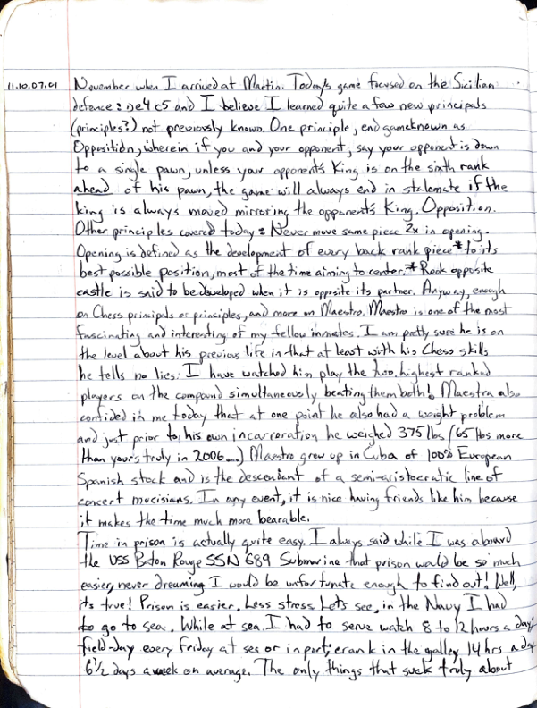

### Image 1  
**11.10.06.01**  
  
Retelling of “The Highlands” without the alien conditions. “Snow in August” also by Pete Hamill takes place in 1947 and follows the life of eleven-year-old Michael Devlin, who is Irish-American. The story is about the friendship between Michael and Rabbi Judah Hirsch, a refugee from Prague. Here in Brooklyn, surrounded by tenements and the smell of Hot dogs, Rabbi Hirsch enchants Michael with stories of ancient wisdom as Michael explains to him the equally wondrous world of baseball. The neighborhood intervenes and the only thing that can save them from the hate all around them is a miracle. Both great books reminiscent of John Grisham’s “Painted House.”  
  
**11.10.06.02**  
  
So why am I writing this? Well, I hope and wish Laurence and Courtney will see this one day. I realize that quite possibly no one will read it, but I hope Lauren will somehow find this and read it one day. I am fearful that the future doesn’t seem so bright for me or other incarcerated persons. I was listening to the Glenn Beck radio show yesterday when he played a manifesto of the hacker group “Anonymous” in its entirety which included the “promise” of deleting all of the data on Wall Street on Mon, Oct 10. Pretty lofty threat! Maybe they succeeded, maybe they didn’t. All I can say is that from what I can observe, it looks like the shit is about to hit the fan. So until it does, I intend to write in my journals which I have entitled “Reflections collected by (for an audience of) one, the most amazing person in the world Lauren Courtney (In part I am being selfish because I would like to be remembered). In another, I want to share with you who I am. A journal seems to be the best vehicle for this as your mother is preempting our communicating, irrationally I'd believe.   
  
For the record, the only reason you have not heard from me or seen me since May 14, 2009, is because your mother prevented you. No other reason. Well, I tried, 400 lbs Gorilla in the room person. Other reasons include any other piece of shit I do nothing relatives who although knowing the means and the desire for your well-being pussyfooted around and did nothing when they should have acted. But first and foremost, the #1 reason you haven’t seen or heard from me is Aunt Michelle Lee Norton Courtney Woods. Am I bitter? You’re damn right I am. I refuse to believe you don’t love me or care about me. I believe you are in a bad situation. It takes a considerable amount of effort and ingenuity to connect a pen to paper, put it in an envelope, put an address on that envelope, put a stamp on that envelope, and then deposit that envelope in a mailbox. You may recall the number of times the electricity or water was cut off in the house. You may recall the number of times we were cut off of the home.  
  
  
### Image 2  
**11.10.06.02 (continued)**  
  
- The only reason why that happened was I was incapable of such superhuman feats as putting ink on a check, putting the check in an envelope, putting an address on the envelope, and putting a stamp on that envelope and putting it in the mail.  
  
I wrote you seven separate letters from March to July. In August, I asked my buddy to have his wife find out what was going on, specifically why I hadn’t heard from you or your mother. I see Dr. Martin in January when I was in Texas (a story for another day), and at that time, she told me that she still loves me and thought about me every day (several times). So of course I still love your mom and always will, but that doesn’t mean I can’t be really pissed at her for being such a bitch. Speaking of love, the opposite of love is INDIFFERENCE. Hate and Love are intertwined. So some days I feel like I hate your mom, you can think of it in the context that as I have A great Betrayal. Your mom betrayed me three times, and I have forgiven her. Even in my last letter, I stated simply that I will always love both of you. And of course, this whole situation sucks for you. I mean that I am sorry a thousand times. But I can honestly say I never thought in a million years I would end up ripped from life like I have been. As Tony Ellison always used to say, Fair is a place where you ride the rides. This whole goddamn situation hasn’t been fair. I am sorry. So anyway, my buddy’s wife called; I think in August or so, and she was verbally accosted by your loving mother, stepfather in a tag team match from hell. I wrote your great-aunt and uncle (who at least visit me although it has done nothing else) to say to your mom that she could go fuck herself for all I care. So, anyway, I was reading the Oct 3 Time Magazine when I happened (read) upon an article about- Tea Partiers decrying the horrible state of a society that would actually pay Disability Benefits (SSD Social Security Disability) of families with children diagnosed as ADD/ADHD (Attention Deficit Hyperactivity Disorder). As I wrote in the letter to your mom, who cares whether ADHD exists or not, money is money man. Times are tough and if you can get more money from our tyrannical government then do it!  
  
Well, I have burned up nearly four pages of this Reflection and I haven’t even scratched the surface. Lauren, I think of you many times every day. I will always love you and I am proud of you and miss you. I wish I could see you and hear from you. Well, I just get a 21-page Initial Brief to work on. I’ll talk to you soon.  
  
**11.10.06.03**  
  
Well, I finally got the book “Firstborn” by A.C. Clarke & Stephen Baxter today. As it turns out, Firstborn is the last book of the Time Odyssey trilogy. From the book’s cover: their first act into the Discontinuity, in which Earth was carved into sections from different eras of history, resulted in a patchwork world, dominated by Mankind’s inheritors, including such notables as Alexander the Great, Genghis Khan, and United Nations peacekeeper Bisesa Dutt. For reasons unknown to her, Bisesa entered into communication with an alien artifact of inscrutable purpose and godlike power that eventually returned her to Earth. There, she played an instrumental role in humanity’s race against time to stop a doomsday event: a massive solar storm triggered by the alien Firstborn designed to eradicate all life from the planet. That fate was averted at an inconceivable price. Now, 27 yrs later, the Firstborn are back. This time they aren’t pulling punches; they have sent “quantum” bomb speeding towards Earth. It is a device that human scientists can barely comprehend, that cannot be stopped or destroyed - a bomb that will obliterate the world. Bisesa’s desperate quest for answers sends her first to Mars and then to Mir, which is itself threatened with extinction. The end seems inevitable, but as shocking new insights emerge into the nature of the Firstborn and their chilling plans for humanity, an unexpected ally appears from light-years away.  
Well, that was quite the mouthful. Sometimes the best way to explain something as complicated as a SciFi Space Opera trilogy is its own book jacket from the third book of the trilogy no less.   
  
I am using an Office Depot generic pen to write this. It is the second of four identical pens I have been given each month since working library. I was devastated when I lost the first but quite relieved when I got the one I am writing with now about a week later. Then, I eventually got two more which I fortunately haven’t lost yet. I use the 2nd OD pen so much I splintered its plastic tip. So I put the 2nd's disposable ink assembly into the 3rd (or 4th? From what I understand) this will be the last month of the OD pens, then we will probably get BIC pens with bigger points. I’ll probably find someone to sell one of these OD pens because I love the fine point which lets me write so tiny. It sure is nice to have this notebook. (93 pages left to fill, hopefully with substantially more interesting information.)  
  
**11.10.07.01**  
  
Chess class goes very productive today! My instructor Humberto Romeo Romero has been down for 7 ½ on a 15-year sentence and gets out in March of 2018 two yrs or so from now. I just call him Maestro for short. Maestro is a Mexican doctor, OB/GYN and he says a surgeon, and was a chess grand master at age 12 or 13 in Cuba. Maestro has been a good friend since last November when I arrived at Martin. Today’s game focused on the Sicilian defense 2 Nc6 and I believe I learned quite a few new principles (principals?) not previously known. One principle, known as Opposition, wherein if you and your opponent’s say your opponent’s pawn to a single pawn, unless your opponent’s King is on the sixth rank ahead of his pawn, the game will always end in a stalemate if the King is always moved mirroring the opponent’s King. Opposition. Other principles cover by Never move same piece 2x in opening. Opening is defined as the development of every back